Dalya M. Lateef
Lab. 9
1.3
This tree compares Humans, Neanderthals, and chimpanzees using mitochondrial DNAs. This graph was generated by aligning the DNA sequences, and constructing a tree using MEGA software.
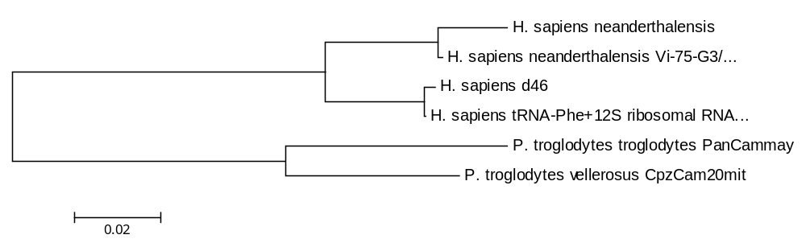

2.2
This tree compares human, mouse, rat, and bovine. To do this, UPGMA was used to construct the tree. This tree was computed for using the nonsynonymous only method. Nonsynonymous refers to substitutions that code for different amino acids. As shown below, the human is more closely related to the bovine.
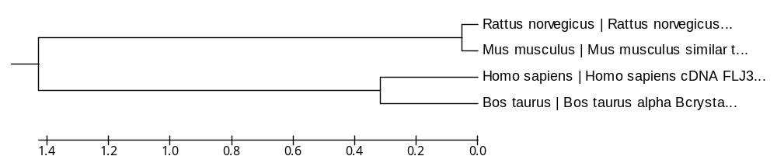

2.3
This tree compares human, mouse, rat, and bovine. To do this, UPGMA was used to construct the tree. This tree was computed for using the synonymous only method. Synonymous refers to substitutions that do not code for different amino acids. As shown below, the human is more closely related to the rat and mouse.
